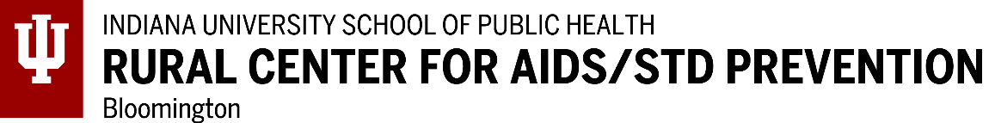

Surgeon General C. Everett Koop HIV/AIDS Research Grant
- - -
-CALL FOR PROPOSALS FOR 2022-2023 SCHOOL YEAR-
(Deadline: November 28, 2022)

In 1986, U. S. Surgeon General C. Everett Koop, MD, ScD, completed a report on the growing AIDS epidemic. He urged the federal government to expand age-appropriate sexuality education for young people and to mount a publicity campaign about the importance of using condoms to prevent HIV transmission. Despite strong opposition, Dr. Koop moved forward with his widespread education plan. In 1988, he prepared the pamphlet, Understanding AIDS, and sent it to nearly every household in the United States. Those 107 million copies provided the U. S. population with plain-spoken, non-judgmental, and much needed answers about HIV transmission and prevention. This pamphlet represented the federal government’s first and only effort to reach every resident with information regarding a serious health issue.
Because of his courageous efforts to educate the public about HIV/AIDS, Dr. Koop became one of the most revered Surgeon Generals, receiving many awards including the Presidential Medal of Freedom and over 50 honorary doctorates. Certainly Dr. Koop is a widely admired and a “public health hero” to those committed to improving our nation’s health. Dr. Koop died February 25, 2013, at age 96.
Dr. Koop’s efforts to educate the public about the transmission and prevention of HIV/AIDS align with the mission of the Rural Center for AIDS/STD Prevention (RCAP) at Indiana University (rcap.indiana.edu). RCAP is headquartered at the Indiana University School of Public Health-Bloomington in the Department of Applied Health Science. RCAP, in partnership with those who admire and value him, has established the Surgeon General C. Everett Koop HIV/AIDS Research Grant, an endowed grant to support doctoral student research related to HIV/AIDS prevention. As an endowed grant, these grants will be awarded annually for perpetuity to encourage and support research by emerging investigators from a wide range of disciplines.
For the 2022-2023 school year, RCAP will award three $2000 grants.
AWARD CRITERIA:
- Applicants must be registered as full time doctoral students at accredited universities in the United States.
- The study must be dissertation or other research occurring or commencing during the 2022-2023 school year.
- The focus of the research must be on issues directly related to HIV/AIDS with implications for prevention.
- The research should be conducted only in the United States.

APPLICATION PROCESS:
The following must be submitted in one email by November 28, 2022, to aids@indiana.edu. Place “Koop Grant 2022” in the subject line.
(Checklist)

_____A description of the proposed study of not more than three pages which presents:
_____(1) study title
_____(2) applicant name, doctoral program and university, and applicant contact information
_____(3) related literature and justification
_____(4) problem of the study
_____(5) methodology (e.g., data collection, sample)
_____(6) study timeframe
_____(7) plan for dissemination of findings
_____(8) budget
______Curriculum vitae (CV) of the applicant
______All materials submitted in one email to aids@indiana.edu. Place “Koop Grant 2022” in subject line.

AWARD STIPULATIONS:
- A copy of the IRB approval of the study must be submitted to RCAP prior funding.
- The researcher will provide updates on the progress of the study.
- The results of the study must be submitted for publication in a referred journal(s) and submitted for presentation at a professional conference (s).
- The following credit must be placed in manuscripts and presentations: This study was supported, in part, by the Surgeon General C. Everett Koop HIV/AIDS Research Grant from the Rural Center for AIDS/STD Prevention, Indiana University School of Public Health-Bloomington.
- Students receiving the research grant will be featured on the RCAP website (rcap.indiana.edu) with a photo and their research abstract and will be listed on an award plaque for the grant at the Indiana University School of Public Health-Bloomington. RCAP may request that a copy of publications from the grant be placed on the RCAP website.
- Each recipient will be asked to write a note of appreciation to Dr. Koop’s family upon receiving the grant.

Recipients of the research grants will be announced by end of December 2022

All application material must be submitted in one email by November 28, 2022, to: aids@indiana.edu

William L. Yarber, HSD
RCAP Senior Director yarber@indiana.edu

